**CH9 Achieving Operational Excellence and Customer Intimacy: Enterprise Applications**

* 1. 企業系統如何幫助企業卓越地運營?
  2. 供應鏈管理系統如何與供應商配合計劃、生產和物流(logistics)？
  3. 客戶關係管理系統(CRM)如何幫助公司達成客戶親密關係(customer intimacy)？
  4. 企業應用程序(enterprise applications)面臨哪些挑戰？企業應用程序如何利用新技術？
* Alimentation Couche-Tard Competes Using Enterprise Systems

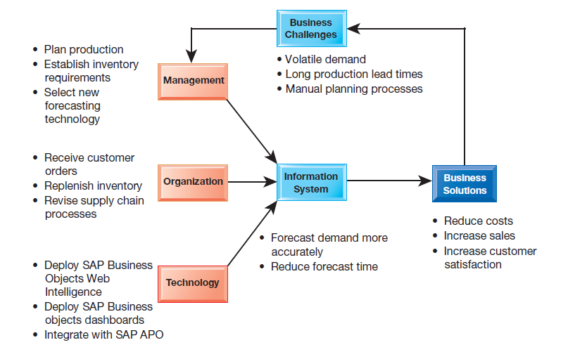

* How did Couche-Tard’s lack of standardized processes affect its business operations? How were Couche-Tard’s employees and supply chain management affected by the adoption of standardized interfaces? Why did Couche-Tard retain its legacy systems instead of replacing them entirely?

1. How do enterprise systems help businesses achieve operational excellence?
   * What are Enterprise Systems?

* resource planning (ERP) systems
* based on a suite of integrated software modules and a common central database.
* Collects data from many divisions of firm for use in nearly all of firm’s internal business activities
* Information entered in one process is immediately available for other processes

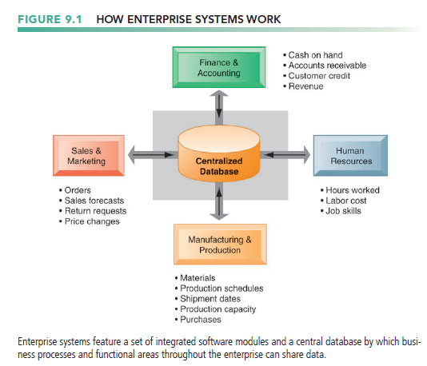

* + Enterprise Software
* Built around thousands of predefined business processes that reflect best practices

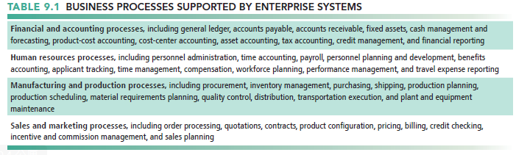

* To implement, firms:
* Select functions of system they wish to use.
* Map business processes to software processes.
  + Use software’s configuration tables for customizing.
* Leading enterprise software vendors include SAP, Oracle, IBM, Infor Global Solutions, and Microsoft
* Versions of enterprise software packages
* designed for small and medium-sized businesses and on-demand software services running in the cloud
  + Business Value of Enterprise Systems
* increasing operational efficiency
* providing firmwide information to help managers make better decisions
* enforce standard practices and data
* everyone does business the same way worldwide.
* respond rapidly to customer requests for information or products
* access to up-to the-minute data on sales, inventory, and production and uses this information to create more accurate sales and production forecasts.
* Include analytical tools to evaluate overall organizational performance
* allow senior management to find out easily at any moment how a particular organizational unit is performing, determine which products are most or least profitable, and calculate costs for the company as a whole.

1. How do supply chain management systems coordinate planning, production, and logistics with suppliers?
   * The Supply Chain

* Network of organizations and processes for:
* Procuring materials, transforming them into products, and distributing the products.
* links suppliers, manufacturing plants, distribution centers, retail outlets, and customers to supply goods and services from source through consumption.
* Upstream supply chain
* the company’s suppliers, the suppliers’ suppliers, and the processes for managing relationships with them.
* Downstream supply chain
* the organizations and processes for distributing and delivering products to the final customers.
* Internal supply chain

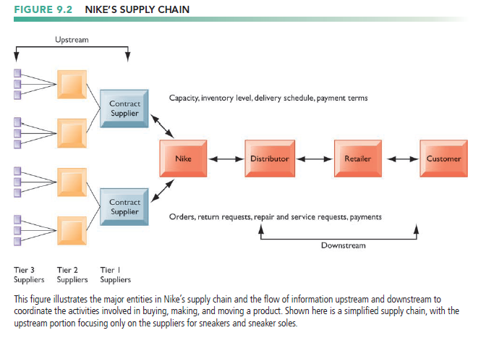

* + Information Systems and Supply Chain Management
* Inefficiencies in the supply chain, or high transportation costs are caused by inaccurate or untimely information
* Can waste up to 25 percent of operating expenses
* Just-in-time strategy
* Components arrive as they are needed
* Finished goods shipped after leaving assembly line
* Safety stock
* Buffer for lack of flexibility in supply chain
* Bullwhip effect(長鞭效益)
* Information about product demand gets distorted as it passes from one entity to next across supply chain

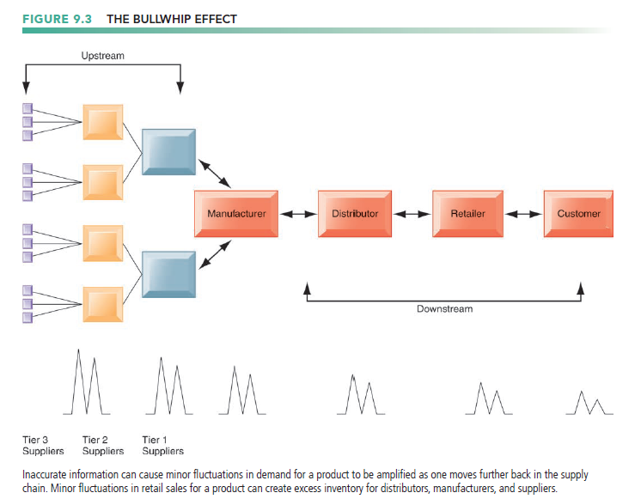

* + Supply Chain Management Software
* Supply chain planning systems
* Model existing supply chain
* Enable demand planning
* Optimize sourcing, manufacturing plans
* Establish inventory levels
* Identify transportation modes
* help companies make better decisions
* Supply chain execution systems
* manage the flow of products through distribution centers and warehouses to ensure that products are delivered to the right locations in the most efficient manner.
  + Global Supply Chains and the Internet
* Global Supply Chain Issues
* Greater geographical distances
* Greater time differences
* Participants from different countries
  + Different performance standards
  + Different legal requirements
* Internet helps manage global complexities
* Warehouse management
* Transportation management
* Logistics
* Outsourcing
* Demand-Driven Supply Chains: From Push to Pull Manufacturing and Efficient Customer Response
* Push-based model (build-to-stock)
  + Earlier SCM systems
  + Schedules based on best guesses of demand
* Pull-based model (demand-driven, build-to-order)
  + Web-based
  + Customer orders trigger events in supply chain

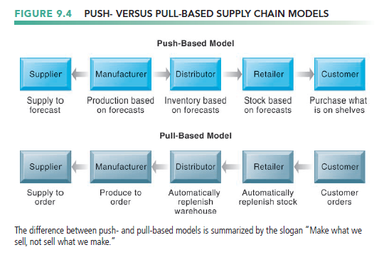

* Internet enables move from sequential supply chains to concurrent supply chains
  + Complex networks of suppliers can adjust immediately

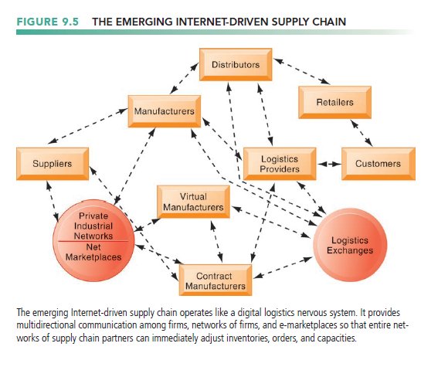

* + Business Value of Supply Chain Management Systems
* Match supply to demand; reduce inventory levels
* Improve delivery service
* Speed product time to market
* Use assets more effectively
* Reduced supply chain costs lead to increased profitability
* Total supply chain costs can be 75 percent of operating budget
* Increase sales

1. How do customer relationship management systems help firms achieve customer intimacy?
   * What is Customer Relationship Management?

* Customer relationship management (CRM)
* Knowing the customer
* In large businesses, too many customers and too many ways customers interact with firm
* CRM systems
* Capture and integrate customer data from all over the organization
* Consolidate and analyze customer data
* Distribute customer information to various systems and customer touch points across enterprise
  + touch point (also known as a contact point) is a method of interaction with the customer
* Provide single enterprise view of customers

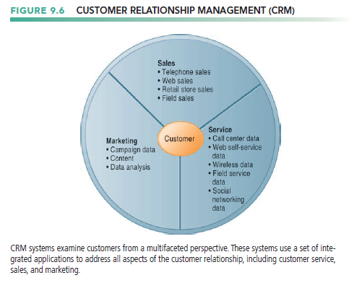

* + Customer Relationship Management Software
* Preface
* Packages range from niche tools to large-scale enterprise applications.
* Partner relationship management (PRM)
  + Integrating lead generation, pricing, promotions, order configurations, and availability
  + Tools to assess partners’ performances
* Employee relationship management (ERM)
  + Setting objectives, employee performance management, performance-based compensation, employee training
* Sales Force Automation
* help sales staff increase productivity by focusing sales efforts on the most profitable customers, those who are good candidates for sales and services.
* provide sales prospect and contact information, product information, product configuration capabilities, and sales quote generation capabilities
* Customer Service
* provide information and tools to increase the efficiency of call centers, help desks, and customer support staff.
* Assigning and managing customer service requests, Web-based self-service capabilities
* Marketing
* Capturing prospect and customer data, scheduling and tracking direct-marketing mailings or e-mail, cross-selling

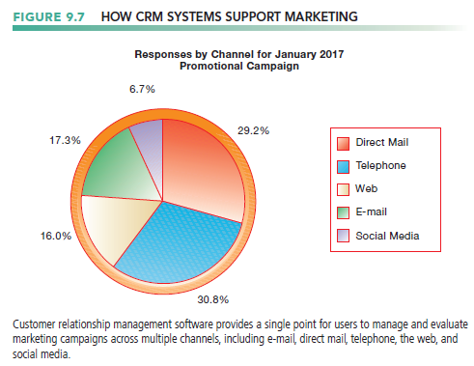

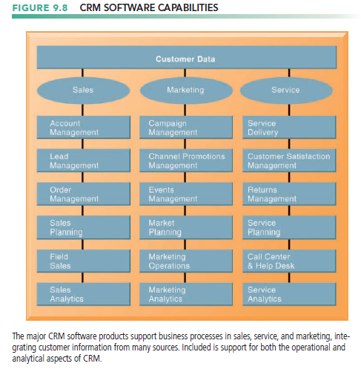

* + Operational and Analytical CRM
* Operational CRM
* Customer-facing applications such as sales force automation, call center and customer service support, and marketing automation
* Analytical CRM
* analyze customer data generated by operational CRM applications to provide information for improving business performance.
* Based on data warehouses populated by operational CRM systems and customer touch points and other sources that have been organized in data warehouses
* analytic platforms for use in online analytical processing (OLAP), data mining, and other data analysis techniques
* Another important output of analytical CRM is the customer’s lifetime value to the firm.
* Customer lifetime value (CLTV)
  + based on the relationship between the revenue produced by a specific customer, the expenses incurred in acquiring and servicing that customer, and the expected life of the relationship between the customer and the company

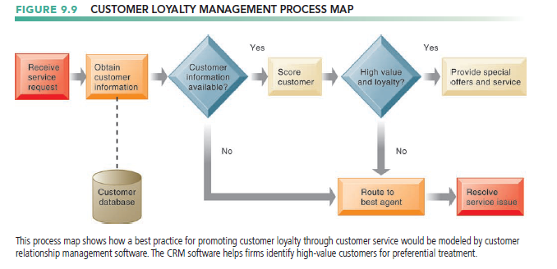

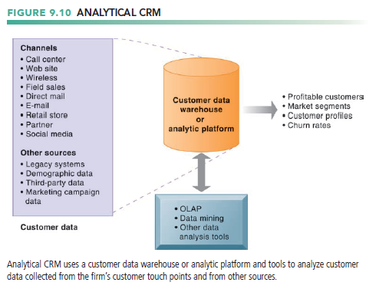

* + Business Value of Customer Relationship Management Systems
* Increased customer satisfaction
* Reduced direct-marketing costs
* More effective marketing
* Lower costs for customer acquisition/retention
* Increased sales revenue
* Churn rate
* Number of customers who stop using or purchasing products or services from a company
* Indicator of growth or decline of firm’s customer base

1. What are the challenges that enterprise applications pose, and how are enterprise applications taking advantage of new technologies?
   * Enterprise Application Challenges

* Highly expensive to purchase and implement enterprise applications
* Technology changes
* Business process changes
* Organizational learning, changes
* Switching costs, dependence on software vendors
* Integrating cloud applications
* Data standardization, management, cleansing
  + Next-Generation Enterprise Applications
* Preface
* Enterprise solutions/suites
  + Make applications more flexible, Web-enabled, integrated with other systems
* SOA standards
* Open-source applications
* On-demand solutions
* Cloud-based versions
* Functionality for mobile platform
* Social CRM and Business Intelligence
* Incorporating social networking technologies
* Company social networks
* Monitor social media activity; social media analytics
* Manage social and Web-based campaigns
* Business Intelligence in Enterprise Applications
* Inclusion of BI with enterprise applications
* Flexible reporting, ad hoc analysis, “what-if” scenarios, digital dashboards, data visualization